

**HUMAN COMPUTER INTERACTION**

**(5CS020)**

**USABILITY REPORT**

**AND**

**WIREFRAME**

**Student Name: SUMIT SHAH**

**Student Code: 2358830**

**Instructor: Mr. Dipesh Shrestha**

**Submitted on: 22-03-2024**

**Word Count:**

**Acknowledgment**

I would like to thank those who ever made this model. Which helps us to increase the creativity of our UI and UX of all screens from websites to mobile apps.

This assignment helps me learn more detail about Schneiderman’s 8 Golden Rules and Nielsen’s 10 Usability Heuristics and understand all the points of these rules. I also found got a chance to read many research papers and explain what I understood after reading all those research papers.

I can draw wireframes and designs with the help of Figma. I understood what should I do and what should not I do with the help of these rules to make my work more effective and cleaner.

**Abstract**

Every organization from small to big organization from private to governmental to profitable to non- profitable organization all need website for different purpose.

Website helps to connect the clients and organization to get information and many more. Nepal government also have implemented the rule to create website for every organization.

**USABILITY REPORT**

**Introduction**

Usability simply means make app, website, pages or any human interaction UI user friendly for all kind of user from old to young and from physically fit to disable people all around the world.

**Literature Review**

**How to Develop Information Systems to Improve**

**Accessible Tourism: Proposal of a Roadmap to**

**Support Development of Accessible Solutions**

This author of this report is MDPI, Basel, Switzerland. This article is an open access article distributed under the term and conditions of the creative commons.

This report is all about making tourism information and service through website or app better for every kind of tourist from all around the world from different nationality, language, and continents.

**Alternative Forms of Tourism: A comparative Study of Website Effectiveness in Promoting UNESCO Global Geoparks and International Dark Sky Parks**

This author of this report is MDPI, Basel, Switzerland. This article is an open access article distributed under the term and conditions of the creative commons

This report is all about making National, Geo Park information and service through websites or apps better for every kind of tourist from all around the world from different nationalities, languages, and continents.

**Analysis**

1. [**https://ntb.gov.np/**](https://ntb.gov.np/)
2. [**https://dnpwc.gov.np/en/**](https://dnpwc.gov.np/en/)
3. [**https://ntb.gov.np/**](https://ntb.gov.np/) **:**

**Schneiderman’s 8 Golden Rules**

1. **Strive for consistency**

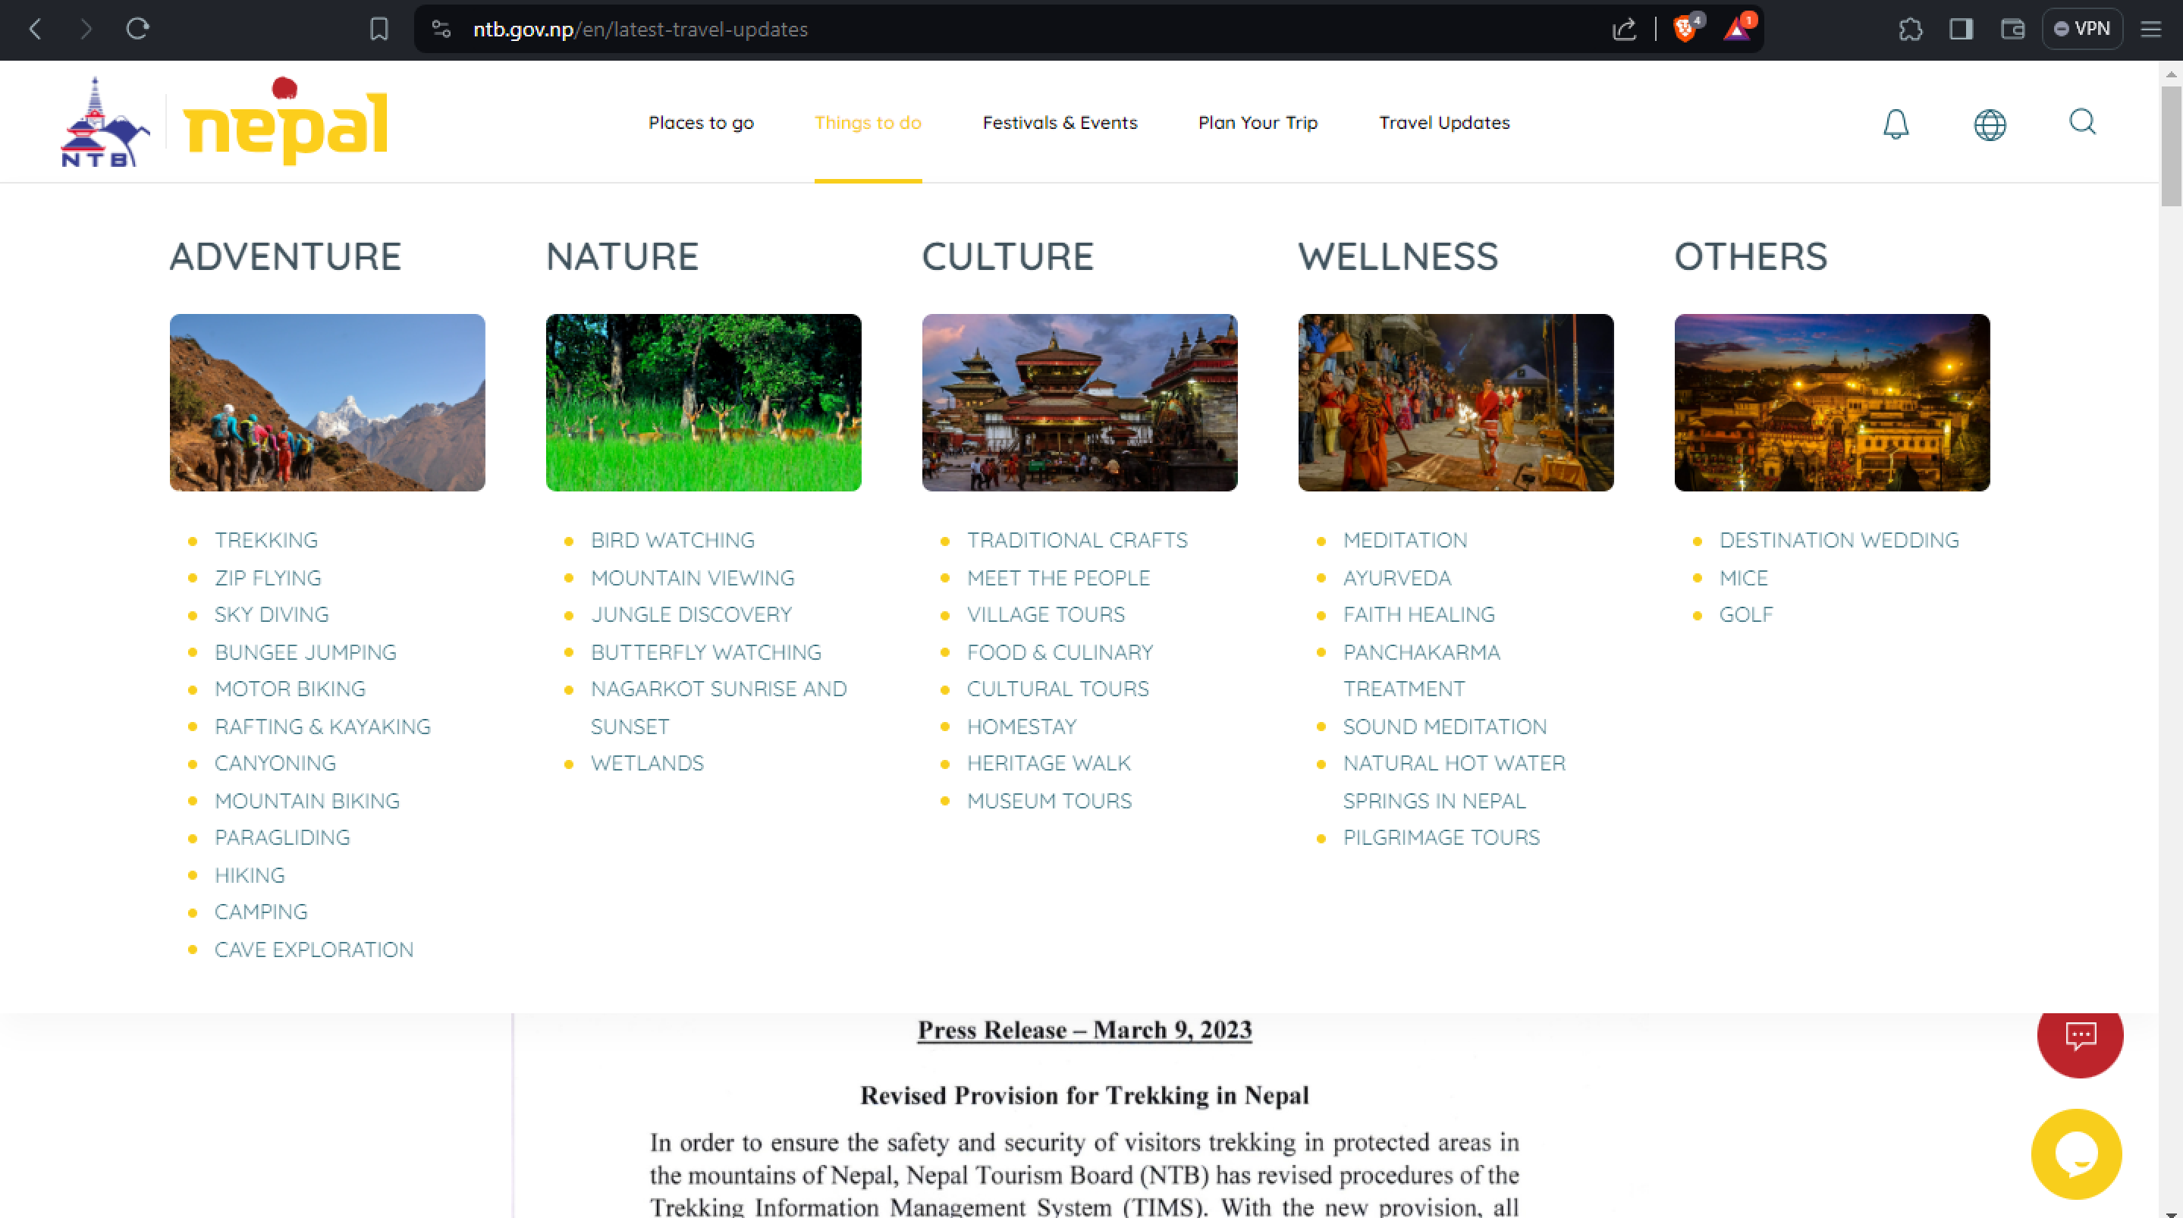

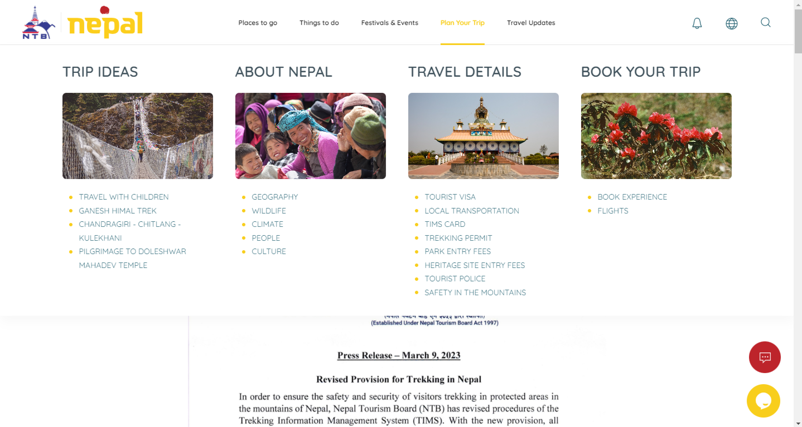

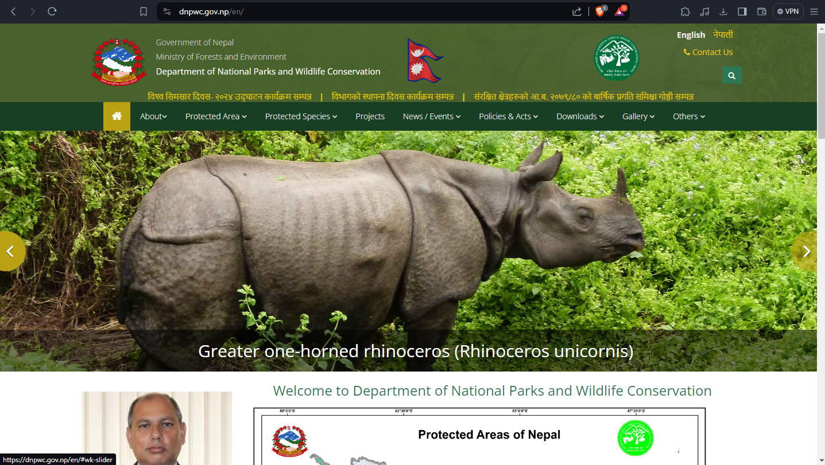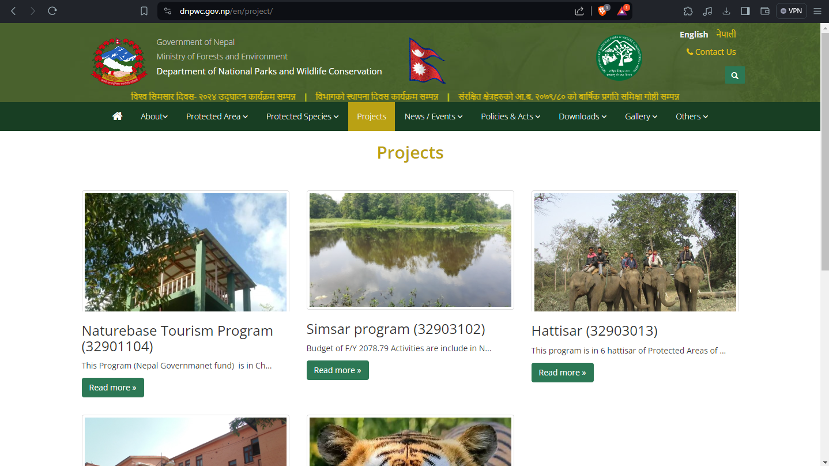

Consistency is available in both of the pages. Whether we go to any page user will not fell that user is outside of the website.

1. **Enable frequent users to use shortcuts**

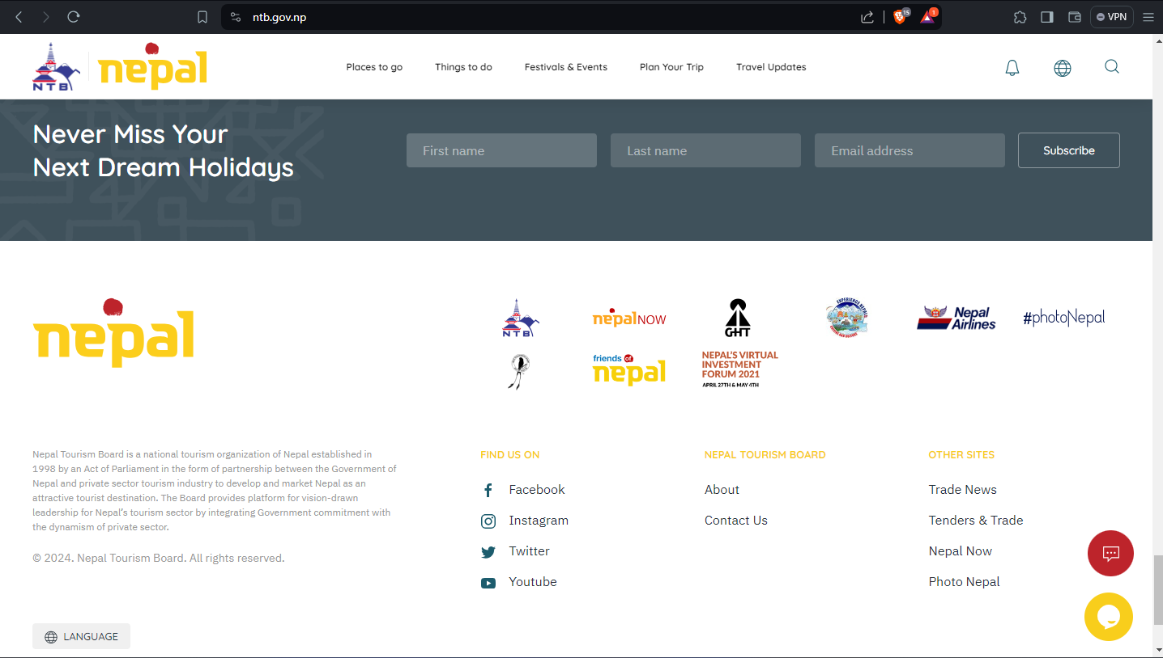

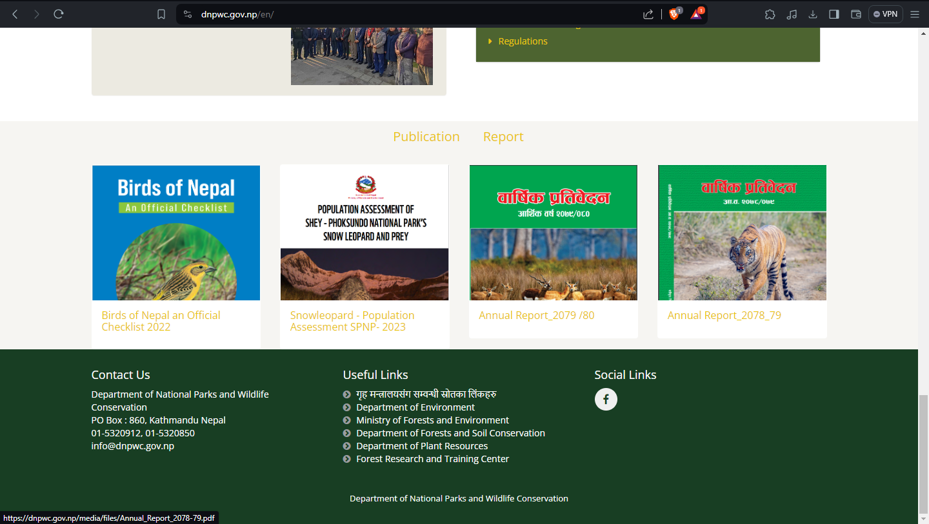

There are many shortcuts which will help the user to go into others site in just clicks. Which same time of user and maintain simplicity.

1. **Offer informative Feedback**

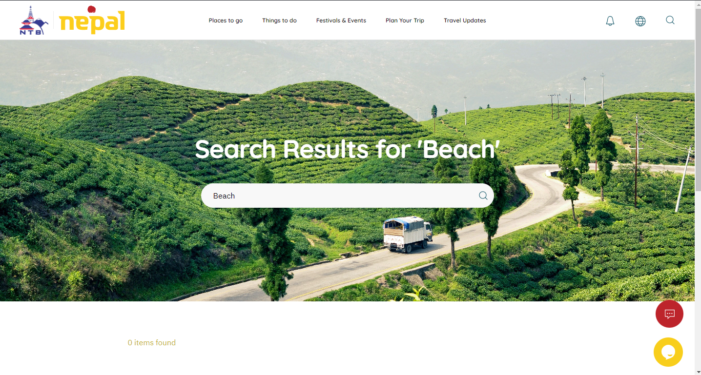

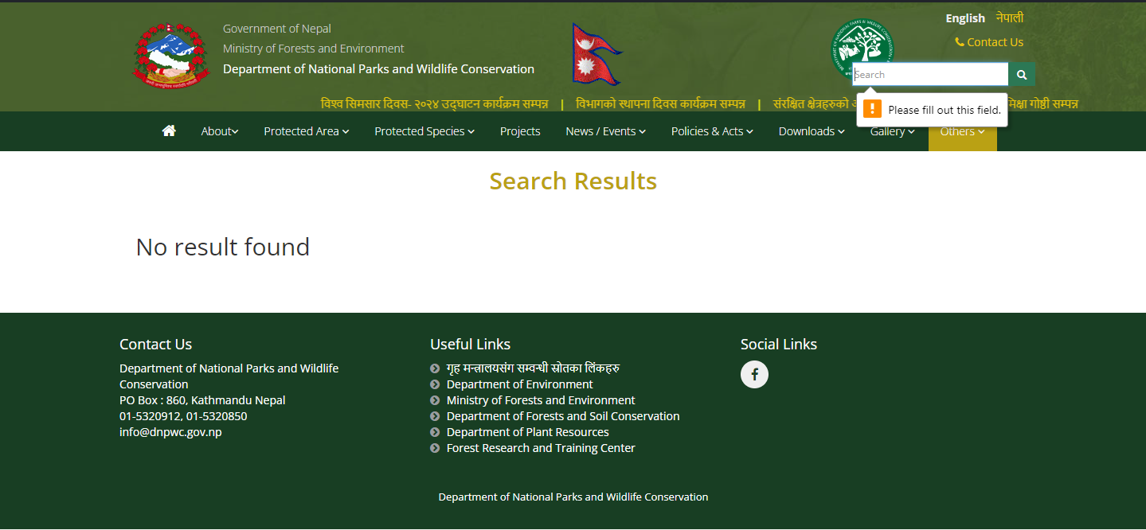

Website provide the informative feedback for different field like search bar, search result and result of searched. Which let the user know what is happening.

1. **Design dialog to yield closure**

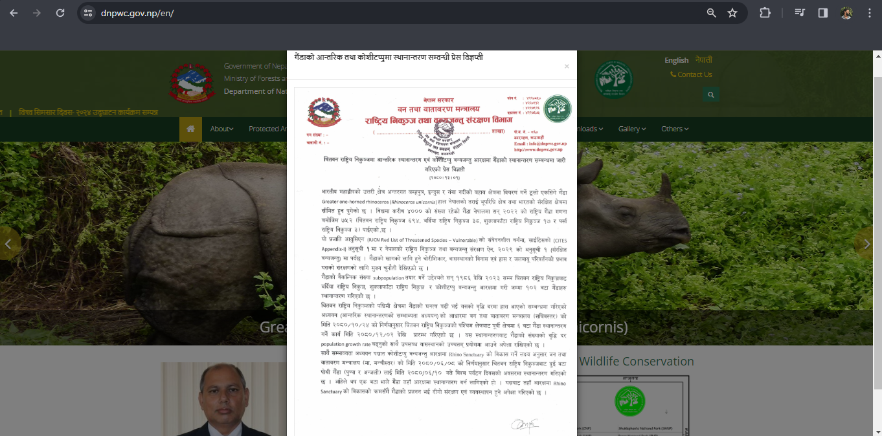

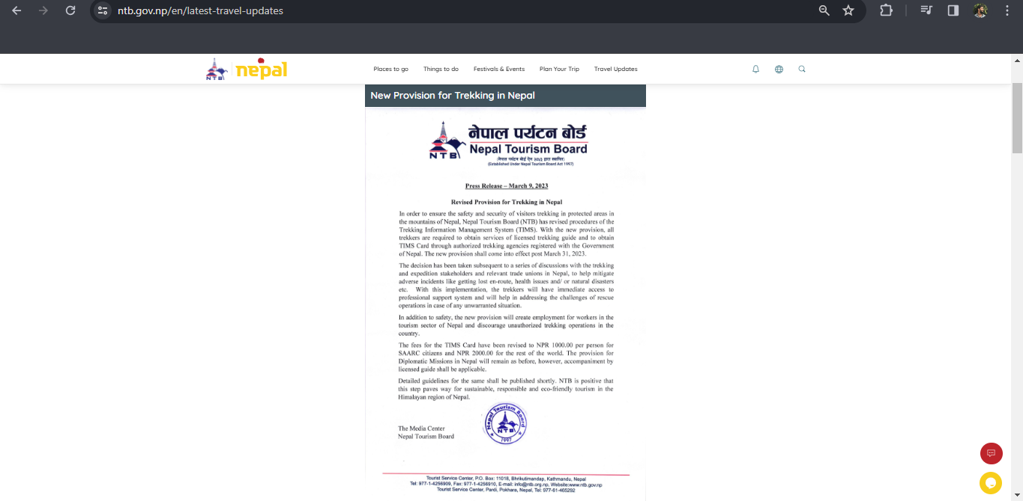

Dialog box papers as soon as user enter in the website which provide latest information and notices. Everyone who enter the website will know about the information or notice.

1. **Offer simple error handling**

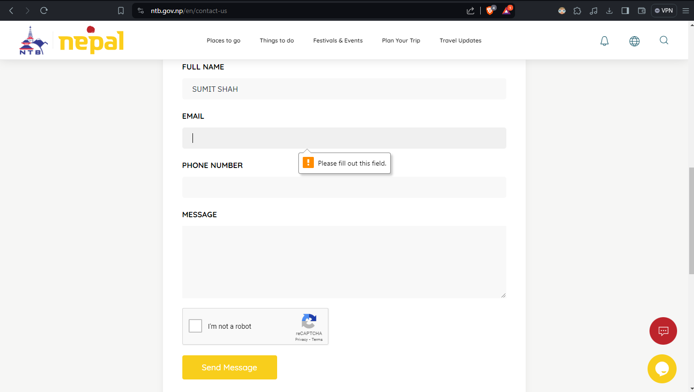

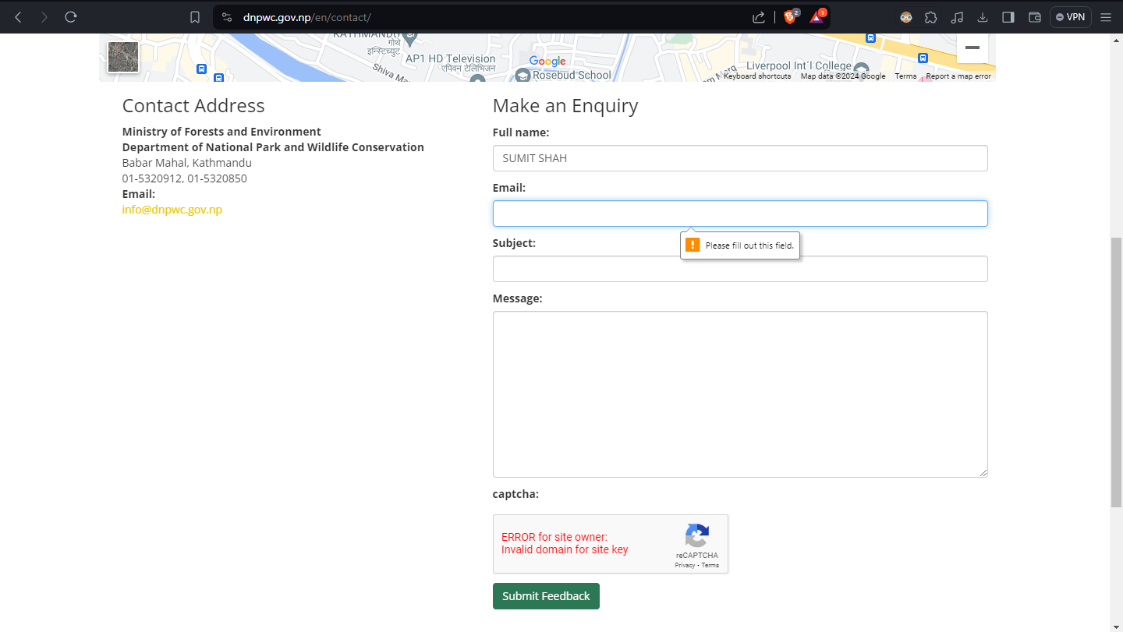

Website handles simple error when user make simple error or not to let user to repeat the same kind of error in future. Make the user use it more perfectly.

1. **Permit easy reversal of actions**

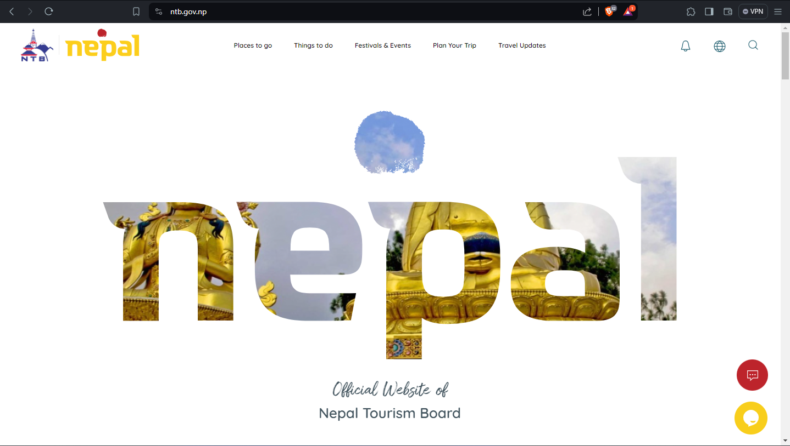

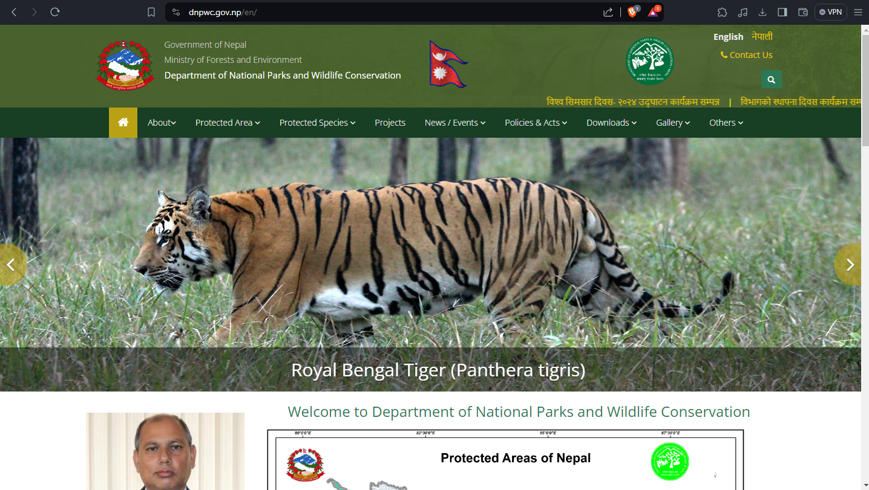

User provided with simple reversal as they can go from one site from another easily by simply clicking. User doesn’t need to search here and there for what they are looking.

1. **Support internal locus of control**



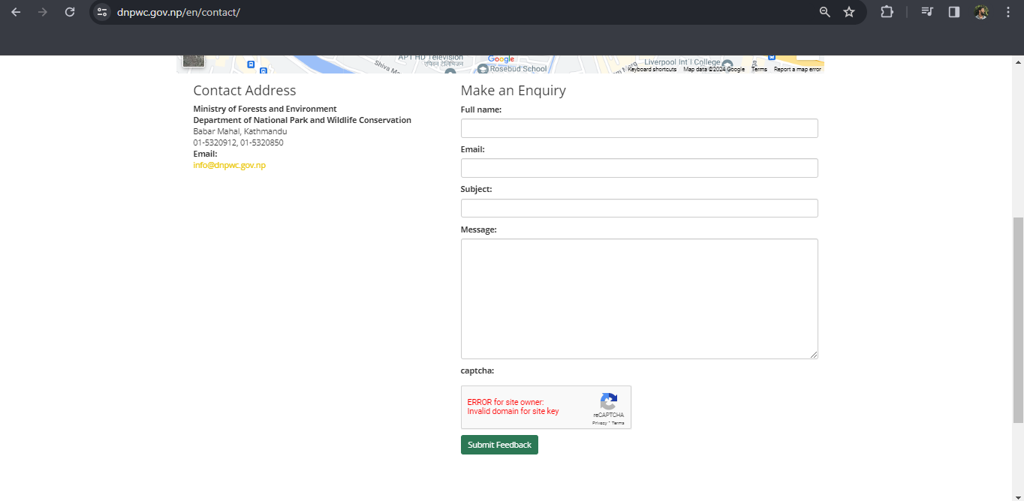

If user have problem or need any kind of support from the website. Website provides them with a short form where they can write what they actually need.

1. **Reduce short-term memory load**



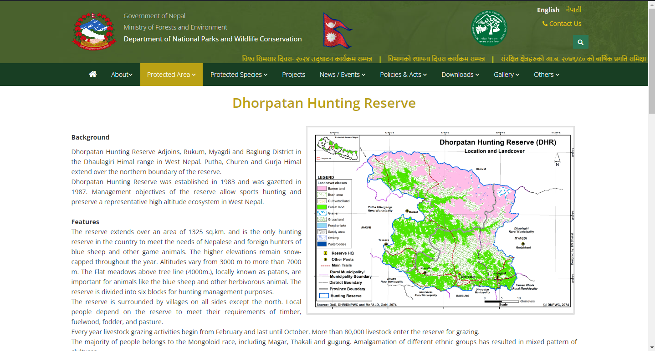

Only specific part or text is shown or available in page. Which makes user to read or see what website want to show to them.

**Nielsen’s 10 Usability Heuristics**

1. **Visibility of system status**

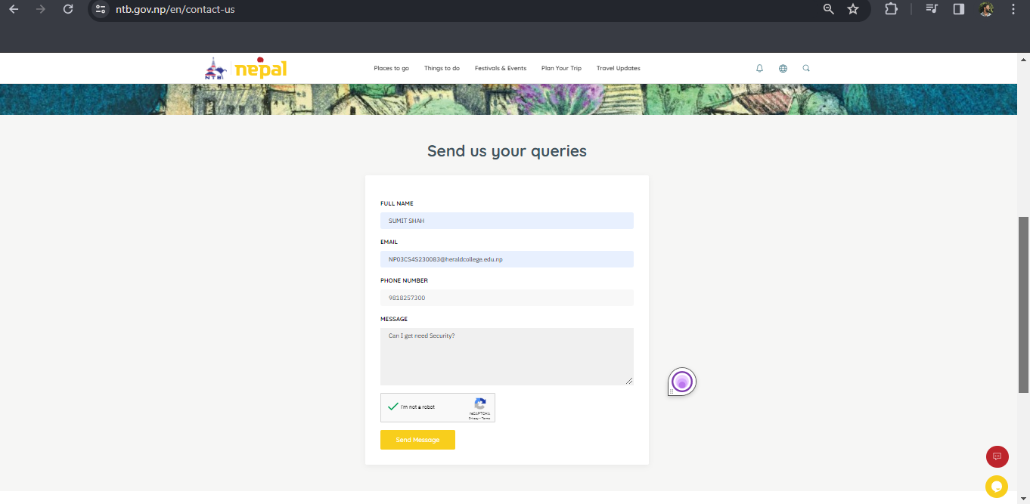

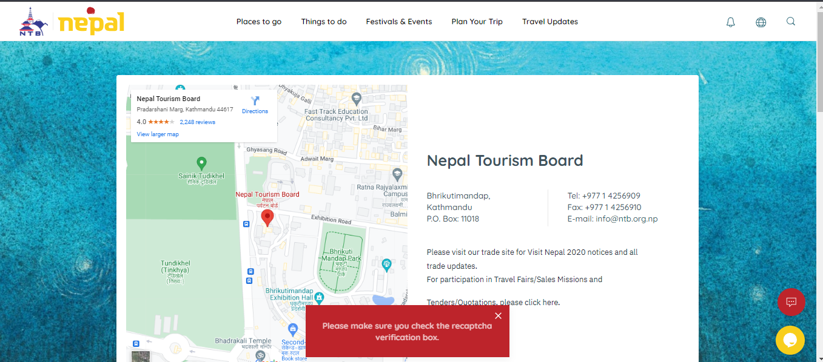

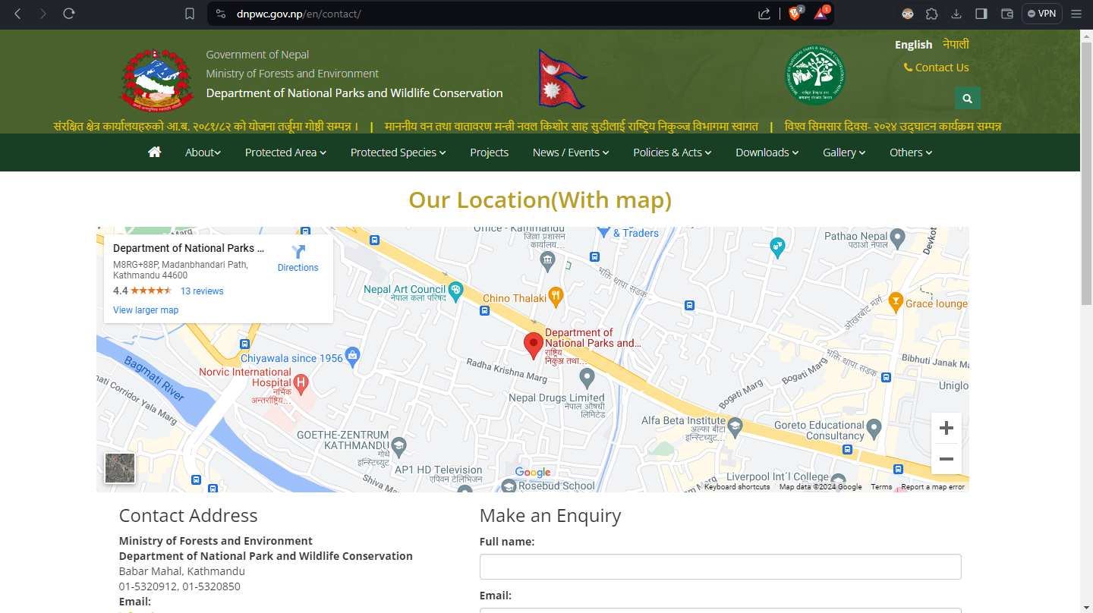

Status show what is actually happening to give the update to the user of there text. Like what is latest update or changes or notice in the website.

1. **Match between system and the real world**

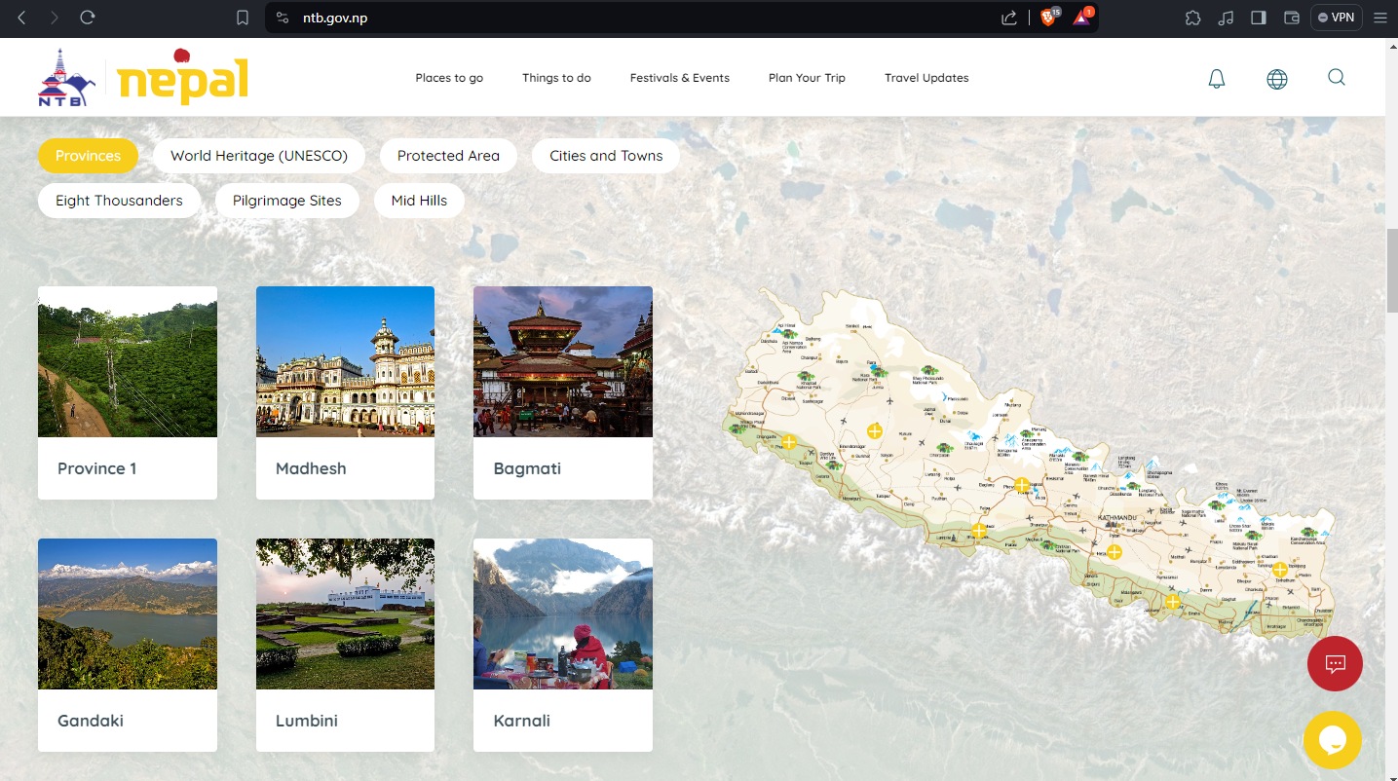

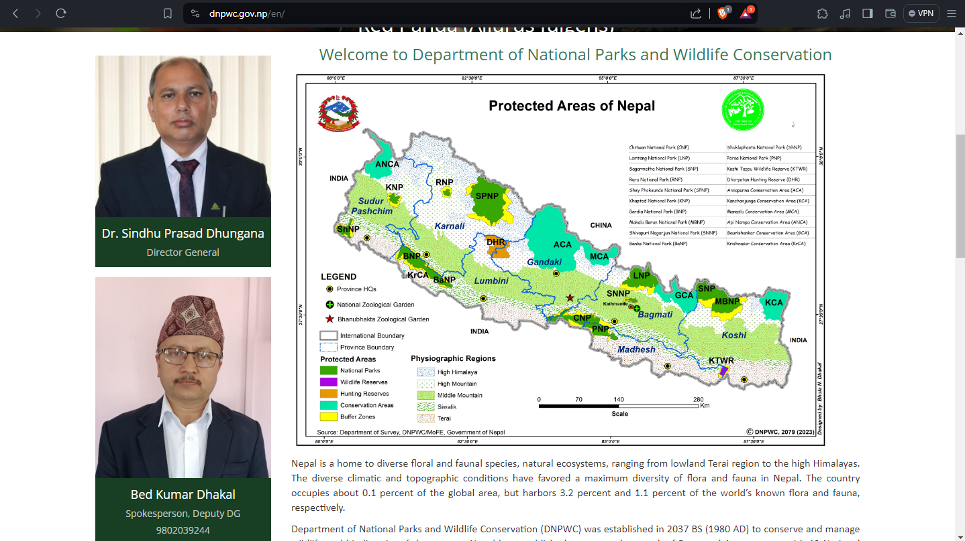

The thing which we can see in real world can be also shown in the website like map, in this Website map is used as the real-world object as to make visitor more comfortable with website.

1. **User control and freedom**

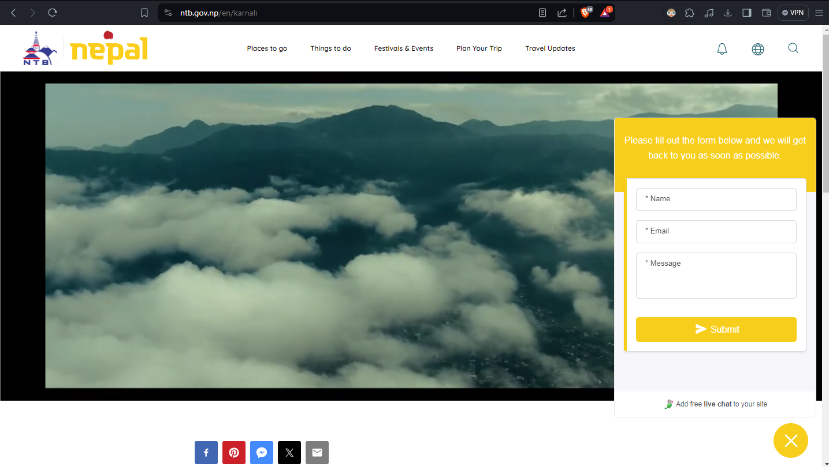

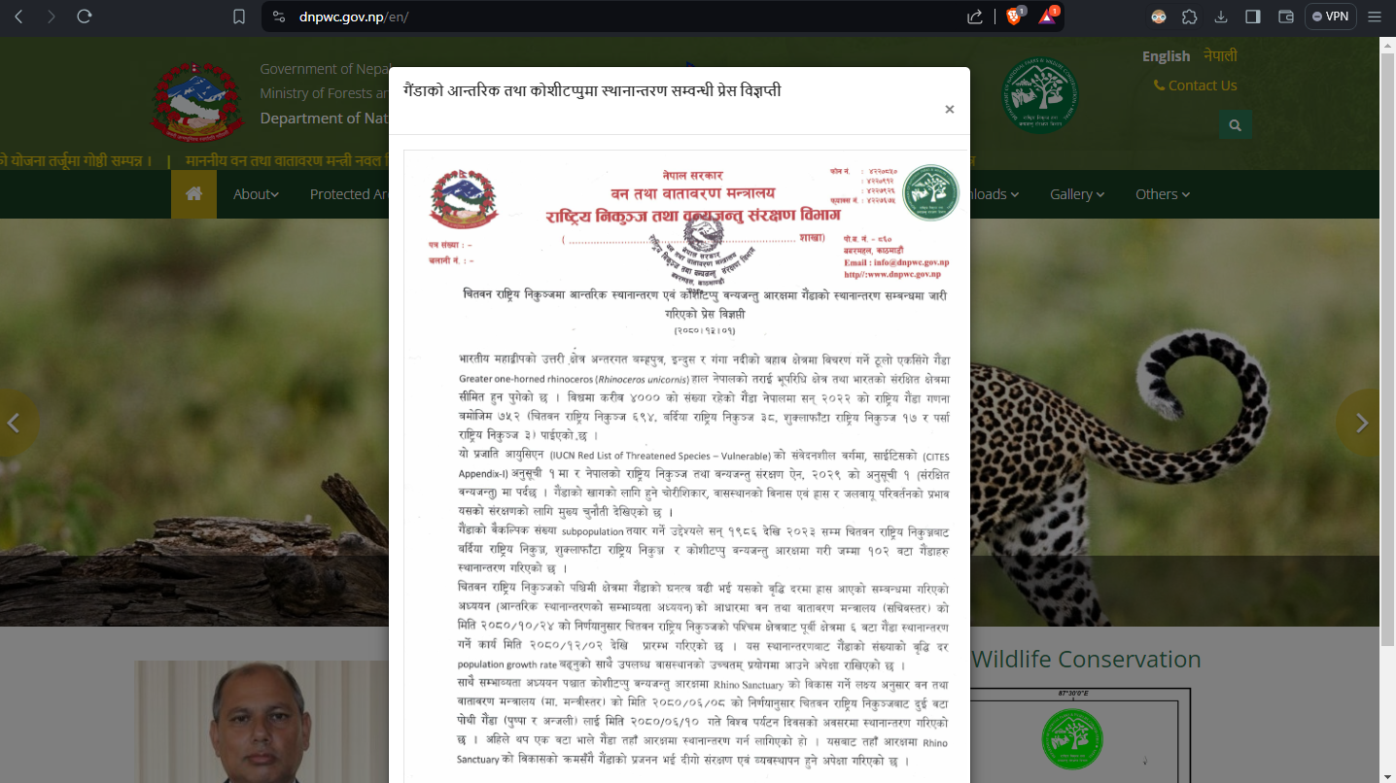

User of the website should be given full control and freedom in the website like closing the dialogue box, popup or any kind of adds. In this two-website user is given freedom to close the dialogue box.

1. **Consistency and standards**

It is one of the repeated rules which simply say that there should be consistency Whether the user go to any part of the website. User should not feel that user is out of the website.

1. **Error prevention**

Error should be prevented as far as possible. If there is error than it makes user to leave the website.

1. **. Recognition rather than recall**

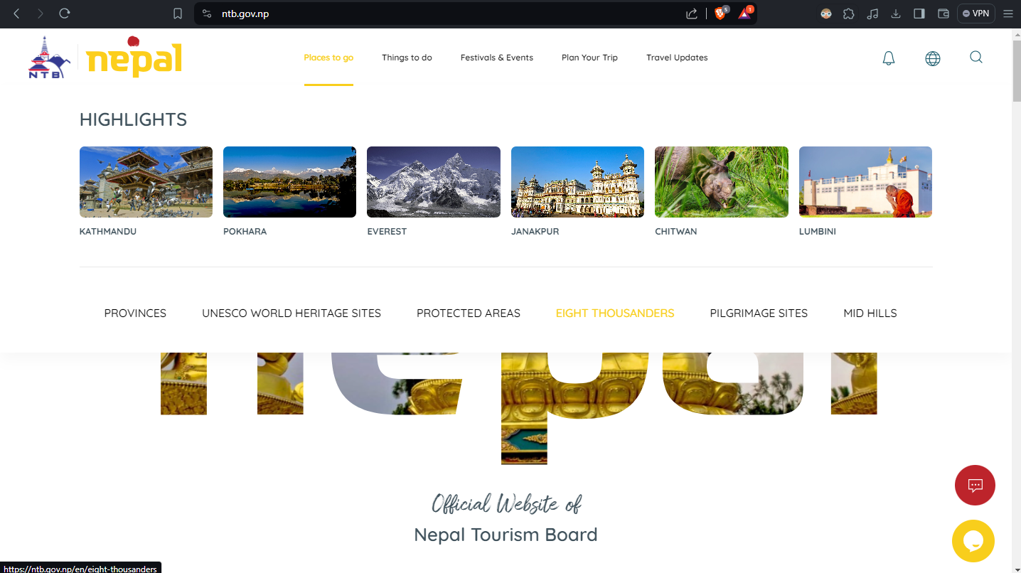

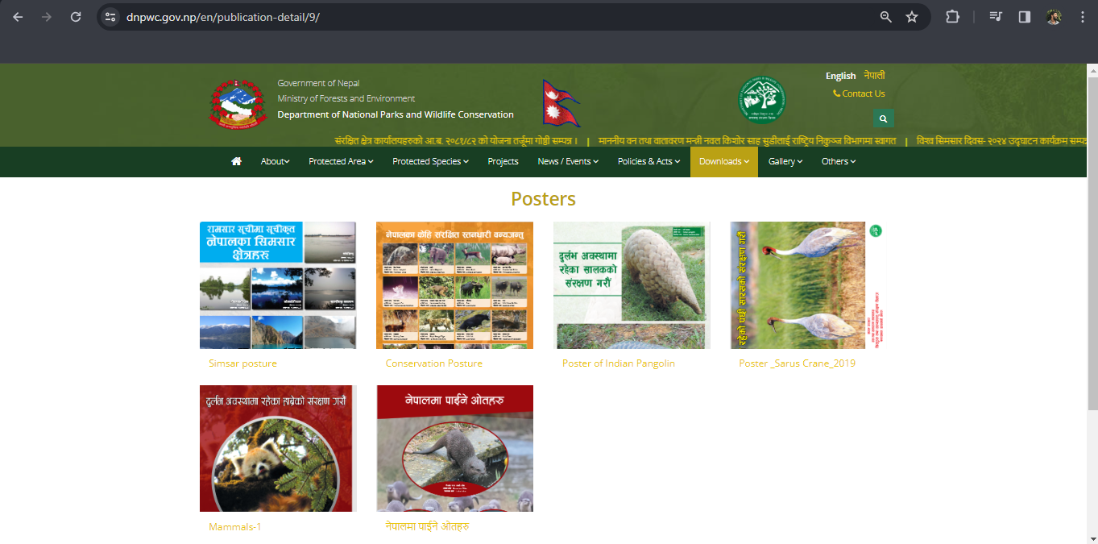

Users should be able to recognize rather than recall. As it helps the user to remember the website and makes website more familiar to the user. The more familiar the user becomes with the website more the use stick or use the website.

1. Flexibility and efficiency of use

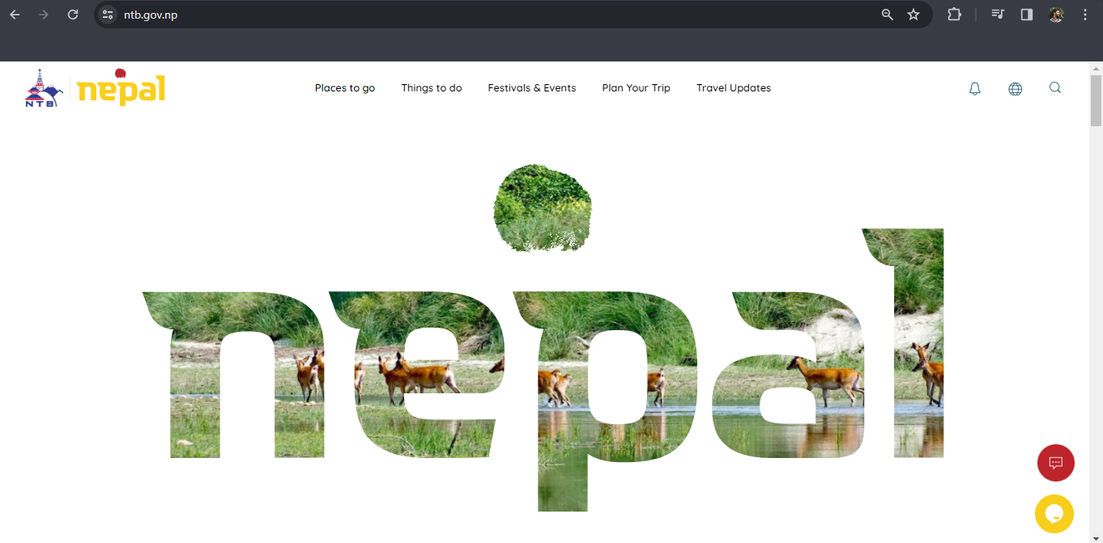

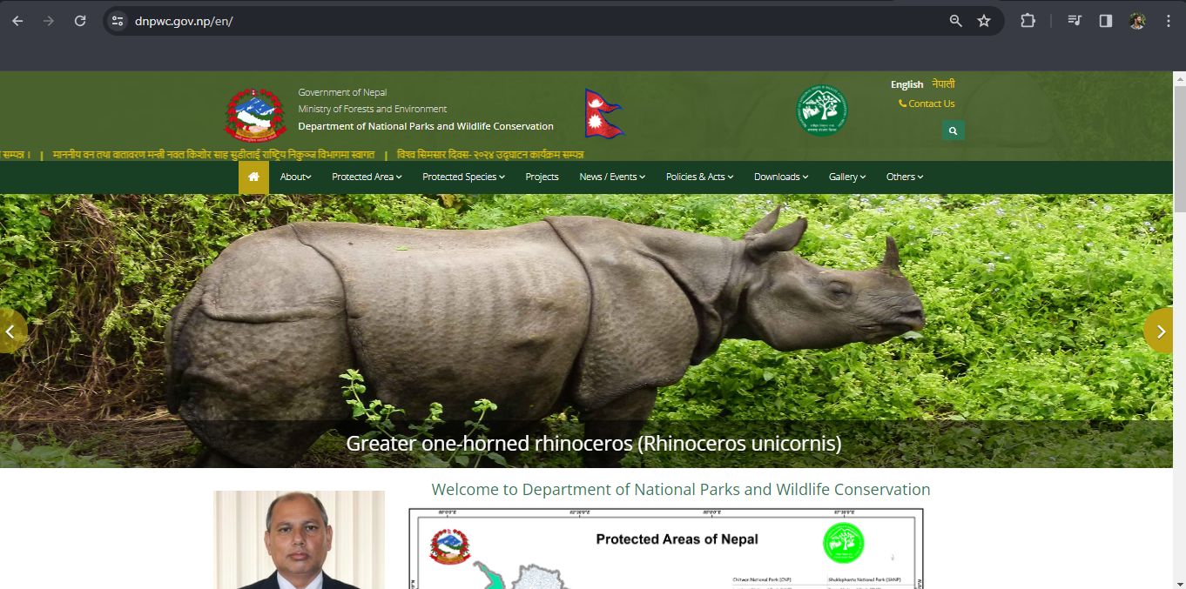

Website should be flexible and efficient to use. Website should be modified as per the need and demand of the user. Which makes the user experience of the website better and better.

1. Aesthetic and minimalist design



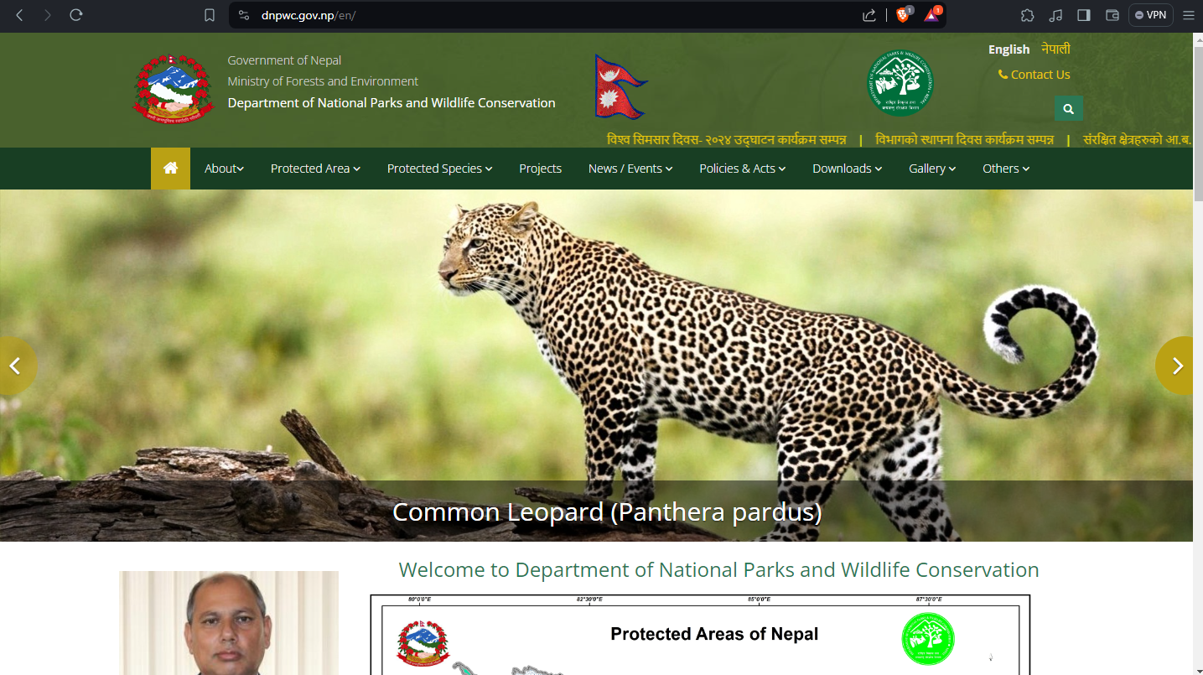

The design of the website should be simple and minimal. This makes visitors to the website clearer and more focused on why they have visited the website. It also makes the website more attractive and gives a premium look.

1. Help users recognize, diagnose, and recover from errors



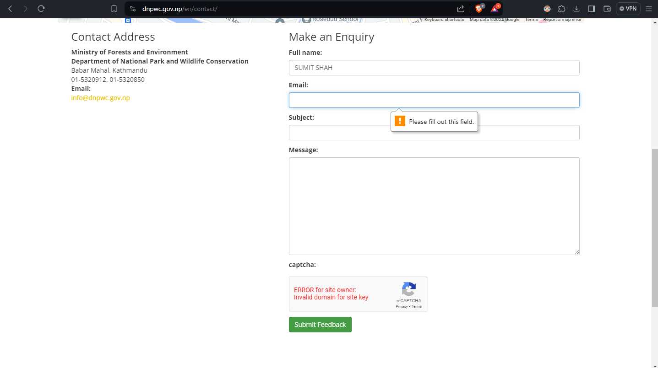

The website should help users recognize, diagnose, and recover from errors. Which will help users not repeat the same kind of errors in the future. It also improves user usability for the website.

1. Help and documentation

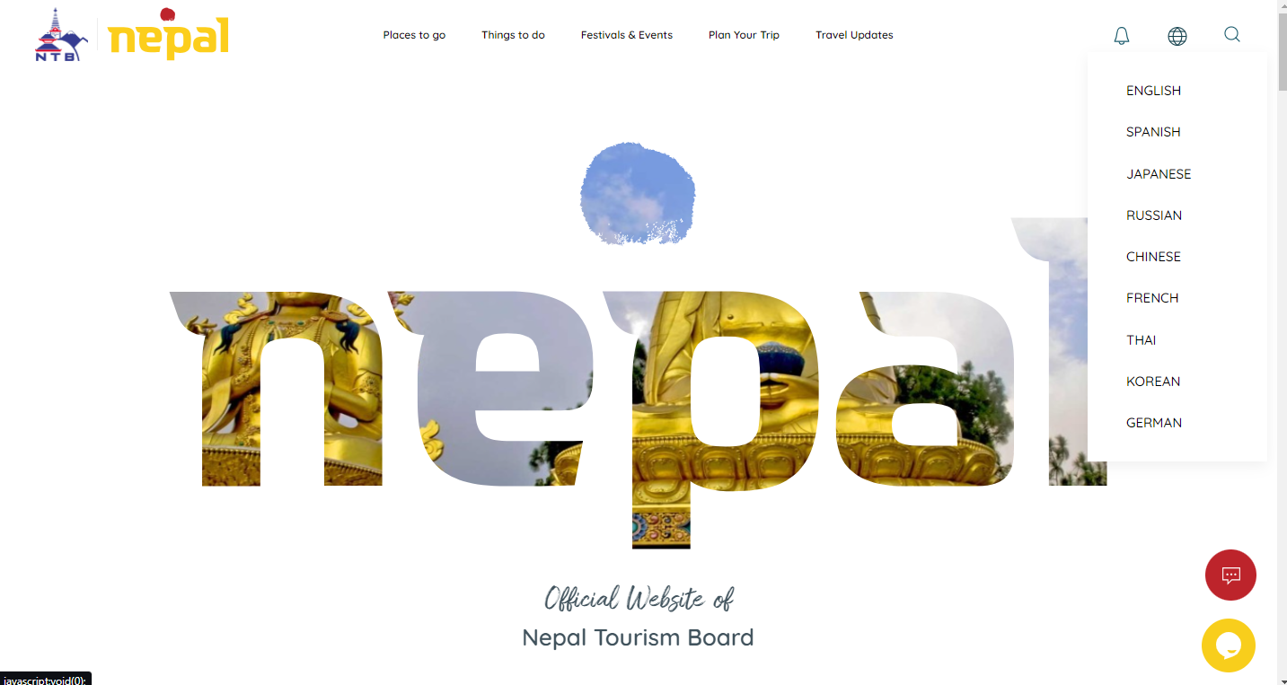

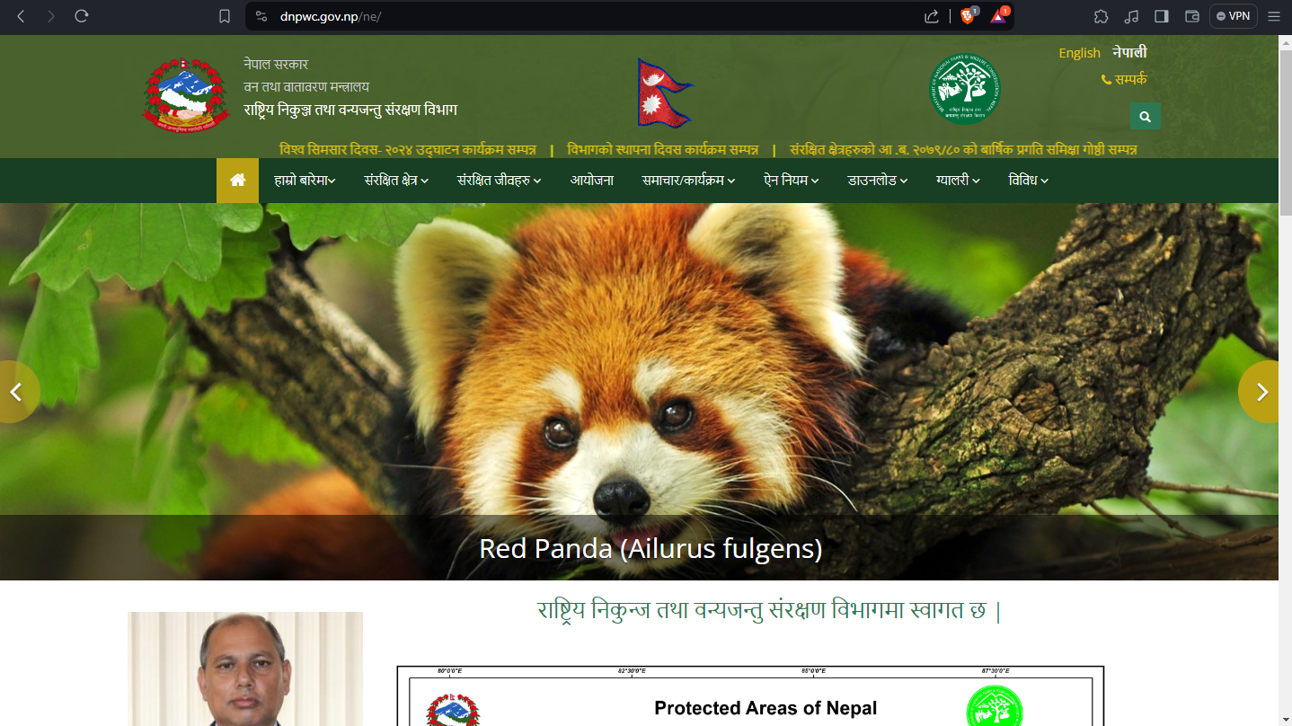

Some users may use different languages, some users may need to contact the user which will help the user to change the language they understand help the user send messages, calls or send emails, or reviews.

Conclusion:

Every website main goal is to provide service or information as per the requirement of the visitor of the website based on what the website is built for. The website should be user friendly and users should feel easy and comfortable while using the website. Use should not be difficult while using the website. The website should provide some guide for new users and contact information as well.

Two websites I have chosen: <https://ntb.gov.np/> and <https://dnpwc.gov.np/en/> are government websites that may have most of the international users. One is the tourism board which is used by tourists all around the world whereas the other is of the National and Wildlife Reserve is also used by tourists and those who like to know more about Nepal use them. These two websites are not only for the information but also for the different kinds of services and those who want to contact them for different purposes. Both of the website follows **Schneiderman’s 8 Golden Rules** and **Nielsen’s 10 Usability Heuristics.** Which makes the website much better and user-friendly.

The website is of the Nepal Government. The website needs to be improved in much of cases. There will be much more improvement as time passes and the website will get better and better.

References

Conceptualization, P.T., C.E. and L.T.; methodology, P.T.; software, P.T.; validation, C.E. and L.T.; formal analysis, C.E. and L.T.; investigation, P.T.; data curation, P.T.; writing—original draft preparation, P.T.; writing—review and editing, C.E. and L.T.; visualization, P.T., C.E. and L.T.; supervision, C.E. and L.T.; project administration, C.E. and L.T.; funding acquisition, C.E. and L.T. All authors have read and agreed to the published version of the manuscript.

Conceptualization, M.X., A.S., N.A., A.K. and N.M.; Methodology, M.X., A.S., N.A., A.K. and N.M.; Software, M.X., A.S., N.A., A.K. and N.M.; Validation, M.X., A.S., N.A., A.K. and N.M.; Formal analysis, M.X., A.S., N.A., A.K. and N.M.; Investigation, M.X., A.S., N.A., A.K. and N.M.; Resources, M.X., A.S., N.A., A.K. and N.M.; Data curation, M.X., A.S., N.A., A.K. and N.M.; Writing—original draft, M.X., A.S., N.A., A.K. and N.M.; Writing—review & editing, M.X., A.S., N.A., A.K. and N.M.; Visualization, M.X., A.S., N.A., A.K. and N.M.; Supervision, N.A.; Project administration, M.X., A.S. and N.A. All authors have read and agreed to the published version of the manuscript.

Appendix

Link:

[**https://www.mdpi.com/2073-431X/13/3/69**](https://www.mdpi.com/2073-431X/13/3/69)

Attribution (CCBY) license <https://creativecommons.org/licenses/by/4.0/>

[**https://www.mdpi.com/2071-1050/16/2/864**](https://www.mdpi.com/2071-1050/16/2/864)

Attribution (CCBY) license

[**https://creativecommons.org/licenses/by/4.0/**](https://creativecommons.org/licenses/by/4.0/)

WIREFRAME

1. Order
2. location

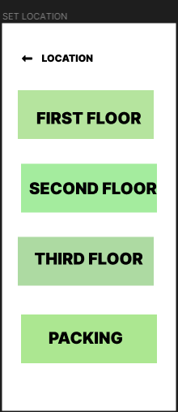

1. Statement

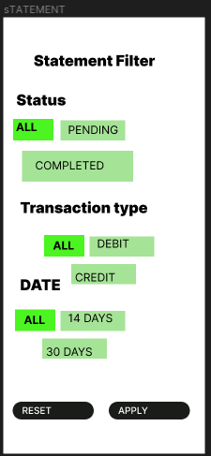

1. Recommendation

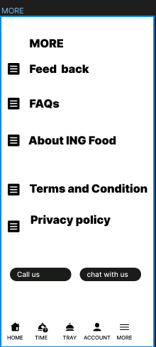

1. Notification

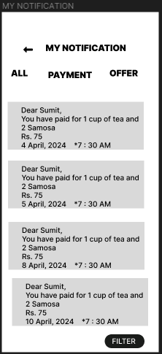

1. Menu

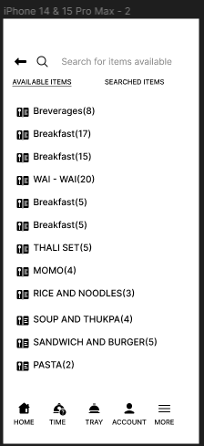

1. Profile

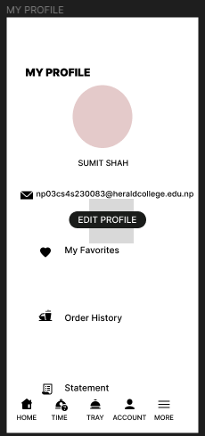

1. More

